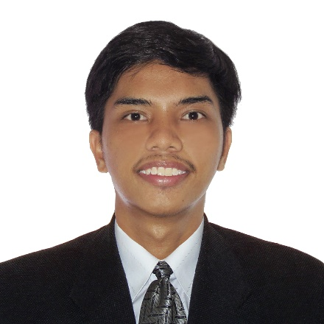

**Irish John S. De Roxas**

Laguile, Taal, Batangas

irishderoxas@gmail.com

**PERSONAL BACKGROUND**

**Date of Birth:** September 6, 2002

**Place of Birth:** Batangas Provincial Hospital Lemery, Batangas

**Sex:**Male

**Status:**Single

**Age:** 20

**Citizenship:** Filipino

**Mother’s Name:** Josefina De Roxas **Occupation:** Piggery

**Father’s Name:** Felipe De Roxas **Occupation:** Piggery

**EDUCATION**

**Primary: -** Governor Vicente Noble Memorial Elementary School (2012-2013)

**Secondary:** - Governor Feliciano Leviste Memorial National High School (2014-2017 Junior High School)

Rizal College of Taal (2018-2020 Senior High School)

**Tertiary:** Rizal College of Taal (present) Taal, Batangas

**CHARACTER REFERENCE:**

**Mr. Robert Allan Suarez**

CSS DEAN

I hereby contained in this resume are true and complete to the best of my knowledge.

**Irish John S. De Roxas**

Researcher



**Jorgel Von O. Pinon**

09128791200

Poblacion 10, Taal, Batangas

jorgelpinon@gmail.com

**PERSONAL BACKGROUND**

**Date of Birth:** May 26, 1997

**Place of Birth:** Poblacion 10, Taal, Batangas

**Sex:** Male

**Status:** Single

**Age:** 25

**Citizenship:** Filipino

**Mother’s Name:** Sherwin Ocampo **Occupation:**

**Father’s Name:** Jeferson Pinon **Occupation:**

**EDUCATION**

**Primary: -** Taal Central School Taal, Batangas.

**Secondary:** - Taal Central School Taal, Batangas.

**Tertiary:** Rizal College of Taal (present) Taal, Batangas

**CHARACTER REFERENCE:**

**Mr. Robert Allan Suarez**

CSS DEAN

I hereby contained in this resume are true and complete to the best of my knowledge.

**Jorgel Von O. Pinon**

Researcher

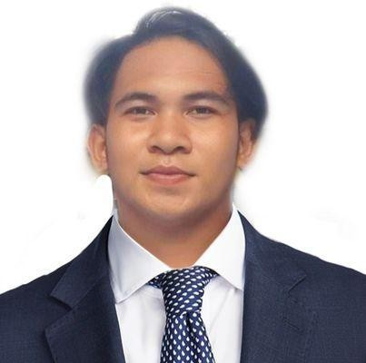

**Ruben C. Sacdalan Jr.**

Taal, Batangas

09566652002

[rubensacdalan14@gmail.com](mailto:rubensacdalan14@gmail.com)

**PERSONAL BACKGROUND**

**Date of Birth:** April 4, 2001

**Place of Birth:** Lemery Provincial Hospital

**Sex:** Male

**Status:** Single

**Age:** 21

**Citizenship:** Filipino

**Mother’s Name:** Emily C, Sacdalan **Occupation:**

**Father’s Name:** Ruben D. Sacdalan **Occupation:**

**EDUCATION**

**Primary: -** Camastilisan Elementary School Calaca, Batangas.

**Secondary:** - Dacanlao G. Agoncillio National Highschool Calaca, Batangas.

**Tertiary:** Rizal College of Taal (present) Taal, Batangas

**CHARACTER REFERENCE:**

**Mr. Robert Allan Suarez**

CSS DEAN

I hereby contained in this resume are true and complete to the best of my knowledge.

**Ruben C. Sacdalan Jr.**

Researcher